
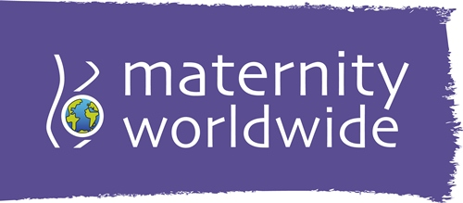
Community Base I 113 Queens Road I Brighton I BN1 3XG
01273 234033
vacancies@maternityworldwide.org
Equal Opportunities Form

Maternity Worldwide is committed to equality of opportunity for staff and volunteers regardless of sex, marital or family status, age, ethnic origin, disability, race, colour, nationality, national origin, creed, sexual orientation, political affiliation, or trade union membership. To ensure that we are attracting volunteers from all sections of society, we would appreciate it if you could complete the following form.

Post Applied For
Gender |  | Female |  |  | Male |  |  | Trans |  | Prefer not to say
Age |  |  |  |  |  |  |  |  |  | Prefer not to say
Do you consider that you have a disability? |  |  |  |  |  |  |  | Yes / No |  | Prefer not to say
How would you describe your sexual orientation? |  |  |  |  |  |  |  |  | Lesbian |  | Gay
Bi-Sexual |  |  | Heterosexual |  |  |  |  |  |  | Prefer not to say
How would you describe your ethnic group?
A. White
□ British □ Irish
□ Any other white background (please write in) …………………………………………………………..
B. Mixed
□ White and black Caribbean □ White and black African □ White and Asian
□ Any other mixed background (please write in) …………………………………………………………..
C. Asian or Asian British
□ Indian □ Pakistani □ Bangladeshi
□ Any other Asian background (please write in) …………………………………………………………..
D. Black or Black British
□ Caribbean □ African
□ Any other black background (please write in) …………………………………………………………..
E. Chinese other ethnic group
□ Chinese
□ Any other ethnic group (please write in) …………………………………………………………..
F. Prefer not to say □

This document will be kept separate from your application. The information you provide will be treated in the strictest confidence and will not be available to members of the appointment panel.
Thank you for completing it.

