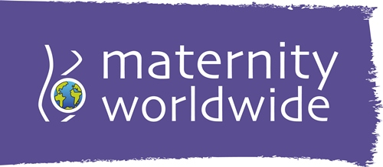
Notelets Order Form
Community Base I 113 Queens Road I Brighton I BN1 3XG
01273 234033 I info@maternityworldwide.org

Please complete this form and return it together with payment to the above address.
Your details:
Name:
Address:
Email:
Delivery details:
Name:
Address:
Order details (please enter quantity of packs required):
Notelets (£4.50 for 10 cards with envelopes):
Post and Packing: Please add £1 for one or two packs, £2 for three or four packs and £3 for five or six packs.
Payment method and total amount:
☐ Cheque ☐ Cash ☐ Credit / Debit card over the phone
☐ Online via JustGiving, reference number of payment:
☐ Online via PayPal, reference number of payment:
Date of payment: Amount:
Signed: Date:

To receive our quarterly eNewsletter packed with info about our projects and events please tick here: ☐ Your details will not be passed on to anyone and you can unsubscribe at any time.


If you are a UK taxpayer and would like us to reclaim 25p for every £1 you have donated now and on future donations at no extra cost to you please tick here ☐
I confirm I have paid or will pay an amount of Income Tax and/or Capital Gains Tax for the current tax year (6th April to 5th April) that is at least equal to the amount of tax that all the charities and Community Amateur Sport Clubs (CASCs) that I donate to will reclaim on my gifts for the current tax year. I understand that other taxes such as VAT and Council Tax do not qualify. I understand the charity will reclaim 25p of tax on every £1 that I have given.

Thank you for your support!

www.maternityworldwide.org
Registered charity no: 1111504

